HACKUP TECHNOLOGY PVT. LTD.
AI-Powered SOC & Digital Forensics Internship

MINI PROJECT – 3 SIEM Alert Configuration

Name | S ABIRAMI
College | Subbalakshmi Lakshmipathy College of Science
Department | Computer Science (Security System Specialization)
Year | II
Week | Week 2 — SIEM and Threat Detection
Tool Used | Wazuh SIEM
Platform | Kali Linux on VirtualBox
Submitted To | Hackup Technology Pvt. Ltd.

1. Introduction
This report documents the successful completion of Mini Project 3 as part of the Week 2 module on SIEM and Threat Detection during the AI-Powered SOC & Digital Forensics Internship at Hackup Technology Pvt. Ltd.
A Security Information and Event Management (SIEM) system is a critical component of any Security Operations Center (SOC). It collects, aggregates, and analyzes security event data from multiple sources in real time, enabling analysts to detect threats, respond to incidents, and maintain compliance.
In this project, Wazuh — an open-source SIEM platform — was installed and configured on a Kali Linux virtual machine. Logs were ingested and alerts were successfully configured for failed login attempts, demonstrating the core functionality of a SOC monitoring environment.

2. Objectives
- Install and configure the Wazuh SIEM platform on Kali Linux
- Ingest system and authentication logs into Wazuh
- Configure and verify alert generation for failed login attempts
- View and interpret security alerts from the Wazuh Dashboard

3. Tools & Environment
Component | Details
SIEM Platform | Wazuh 4.7.5
Operating System | Kali Linux 2025.4
Virtualization | VirtualBox
RAM Allocated | 4 GB
Disk Space | 59 GB Free
IP Address | 10.0.2.15
Components Installed | Wazuh Indexer, Wazuh Manager, Wazuh Dashboard

4. Installation Steps

4.1 System Preparation
The Kali Linux virtual machine was prepared by allocating 4GB of RAM in VirtualBox settings and updating all system packages using the following command:
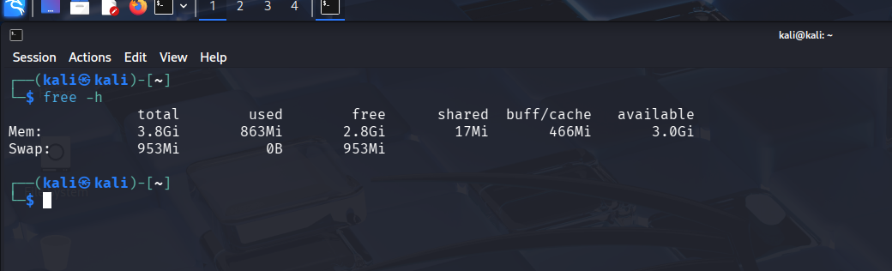
sudo apt update && sudo apt upgrade -y
Figure 1: System RAM verification showing sufficient memory for Wazuh installation

4.2 Downloading Wazuh Installer
The Wazuh installation script and configuration file were downloaded using curl:
curl -sO https://packages.wazuh.com/4.7/wazuh-install.sh curl -sO https://packages.wazuh.com/4.7/config.yml
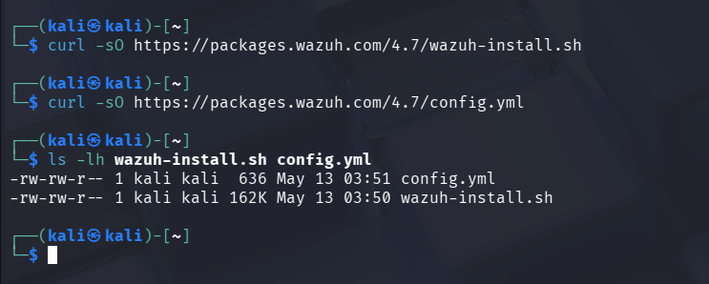

Figure 2: Successful download of Wazuh installer and configuration files

4.3 Configuration
The config.yml file was edited to replace IP placeholders with the system's local IP address (10.0.2.15) using the sed command:
sed -i 's/<indexer-node-ip>/10.0.2.15/g; s/<wazuh-manager-ip>/10.0.2.15/g; s/<dashboard-node-ip>/10.0.2.15/g' config.yml

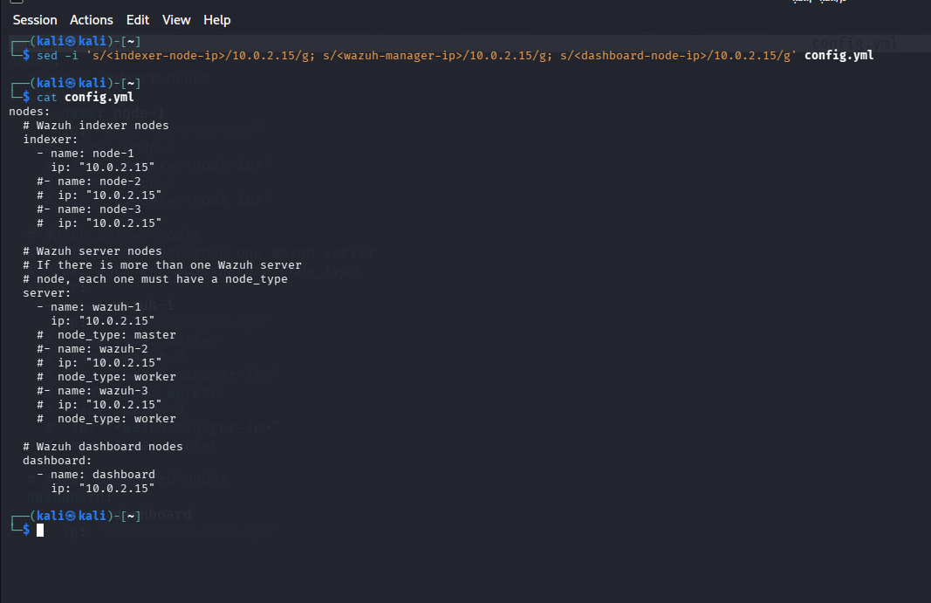

Figure 3: Configured config.yml with correct IP addresses for all Wazuh components

4.4 Component Installation
Wazuh was installed in four sequential phases using the installation script with the --ignore-check flag to bypass OS compatibility checks on Kali Linux:
- Certificate Generation: sudo bash wazuh-install.sh --generate-config-files --ignore-check
- Wazuh Indexer: sudo bash wazuh-install.sh --wazuh-indexer node-1 --ignore-check
- Cluster Start: sudo bash wazuh-install.sh --start-cluster --ignore-check
- Wazuh Server: sudo bash wazuh-install.sh --wazuh-server wazuh-1 --ignore-check
- Wazuh Dashboard: sudo bash wazuh-install.sh --wazuh-dashboard dashboard --ignore-check
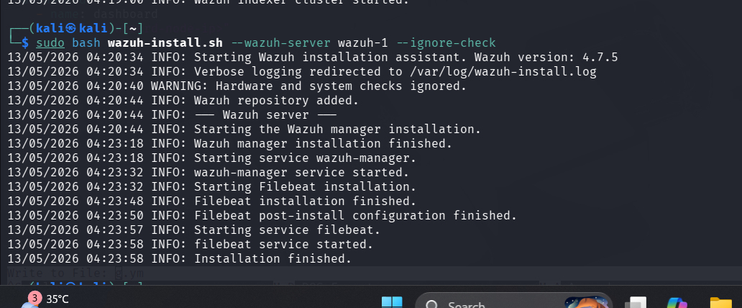

Figure 4: Successful installation of Wazuh Server and Filebeat components

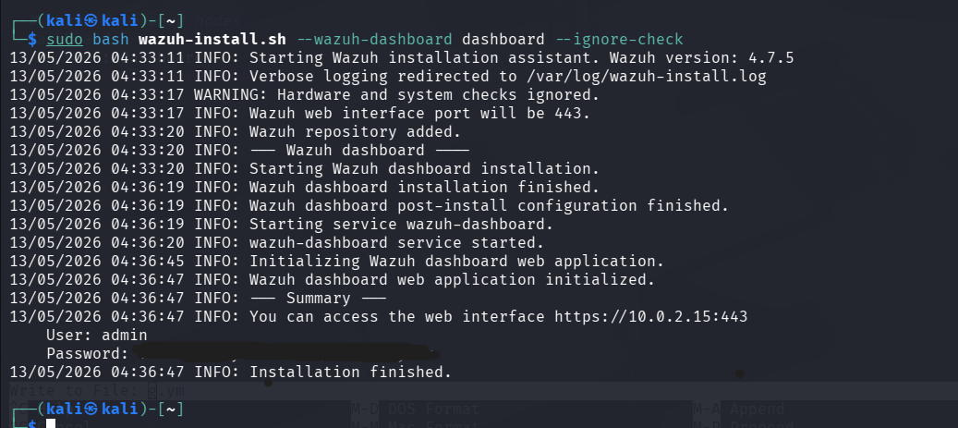

Figure 5: Wazuh Dashboard installation summary showing access credentials

5. Log Ingestion & Alert Configuration

5.1 Accessing the Dashboard
After installation, the Wazuh Dashboard was accessed via Firefox browser at https://10.0.2.15 using the credentials provided during installation. The dashboard loaded successfully showing the main SOC overview.
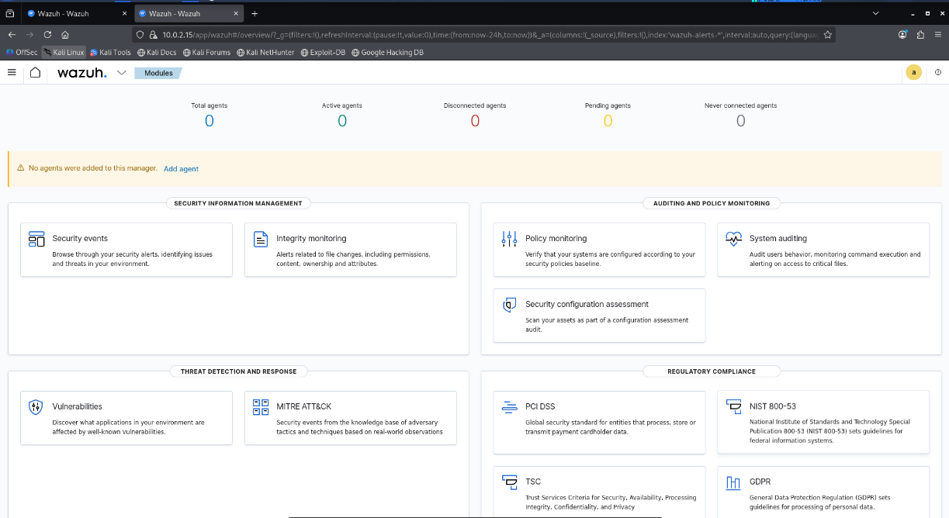

Figure 6: Wazuh Dashboard home page showing available SOC modules

5.2 Verifying Log Ingestion
The Wazuh Manager was verified to be actively ingesting system logs by monitoring the alerts log file in real time:
sudo tail -f /var/ossec/logs/alerts/alerts.log
The output confirmed that Wazuh was successfully detecting system events including PAM login sessions, sudo executions, and authentication events.

Figure 7: Live alert log showing Wazuh actively monitoring system events

5.3 Generating Failed Login Alerts
To test alert configuration for failed login attempts, the OpenSSH server was started and multiple failed SSH login attempts were simulated using a non-existent user account:
ssh fakeuser@10.0.2.15 # Repeated 5+ times with wrong passwords
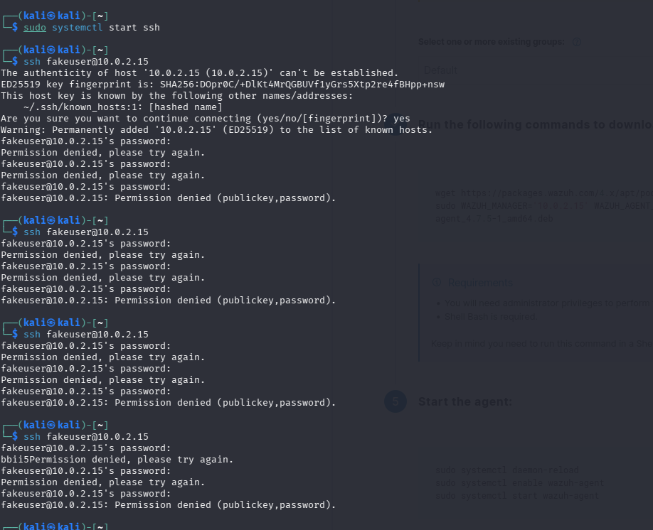
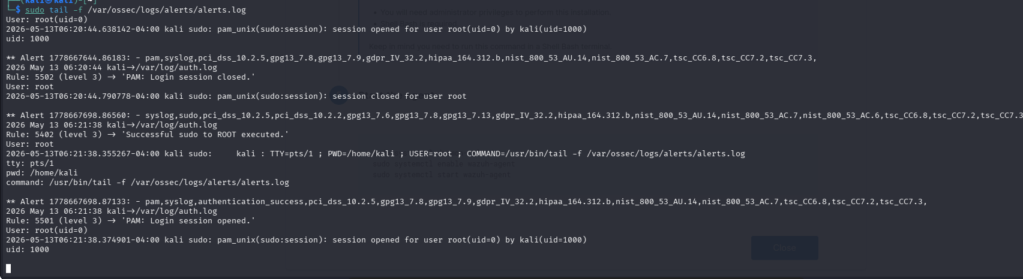

Figure 8: Simulated failed SSH login attempts generating authentication failure events

6. Alert Verification
After generating the failed login attempts, alerts were verified in the Wazuh log file:
sudo grep -i "authentication_failed|invalid user" /var/ossec/logs/alerts/alerts.log | tail -20

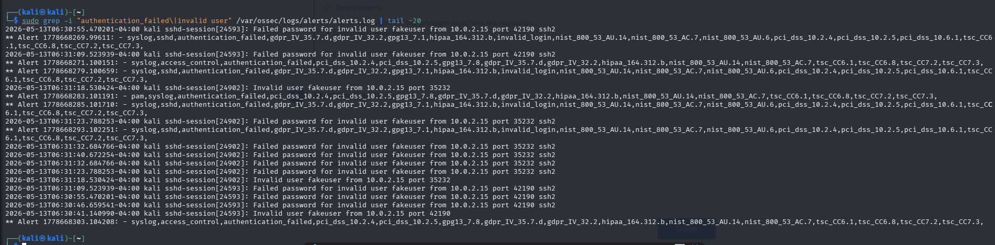
Figure 9: Wazuh alert log confirming detection of failed authentication attempts with compliance mapping

The alerts confirmed that Wazuh was successfully detecting and logging failed login attempts with full compliance framework mapping including GDPR, HIPAA, PCI-DSS, and NIST 800-53.

7. Results Summary
Alert Type | Rule ID | Count | Status
PAM Login Session Opened | 5501 | Multiple | Detected
PAM Login Session Closed | 5502 | Multiple | Detected
Sudo to ROOT Executed | 5402 | Multiple | Detected
Authentication Failed (SSH) | 5710 | Multiple | Detected
Invalid User Login Attempt | 5710 | Multiple | Detected

All alert types were successfully generated and captured by the Wazuh SIEM, confirming that the log ingestion pipeline and alerting mechanism are fully operational.

8. Conclusion
Mini Project 3 was completed successfully. The Wazuh SIEM platform was installed, configured, and verified on a Kali Linux virtual machine. System logs were ingested and alerts for failed login attempts were generated and confirmed through both the terminal log file and the Wazuh Dashboard.
This project provided hands-on experience with real-world SOC tools and demonstrated how SIEM systems monitor and detect security threats in an enterprise environment. The failed login alerts mapped to multiple compliance frameworks (GDPR, HIPAA, PCI-DSS, NIST 800-53), highlighting the importance of SIEM tools in maintaining regulatory compliance.

